1. **Identify the sockets that belong to the connection and their TCP state.**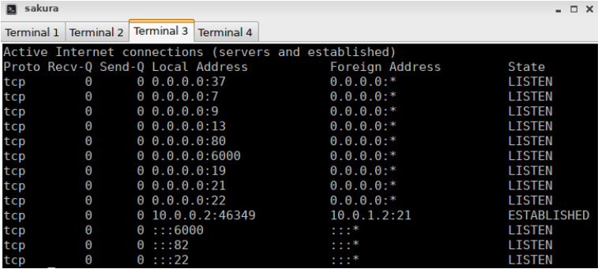
2. **Identify the *three-way-handshaking* and the termination of the tcp connection.** 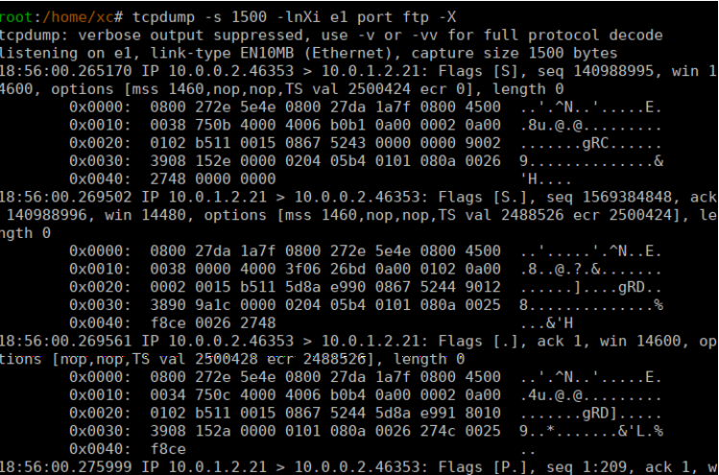
3. **Look for the segment where the password has been sent, and where the command “dir” has been executed.**
   1. Password:

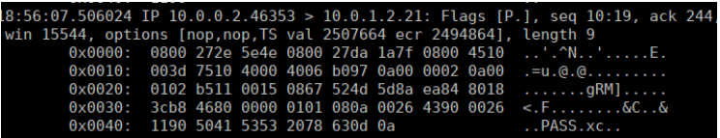

* 1. Command “dir”:

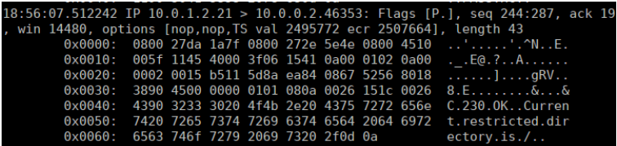

1. **Estimate the effective transmission speed of the connection:**

Length = 1448

Time intervals from 19:31:52 to 19:31:54 (2 seconds)

Effective Transmission Speed = 724 bps

1. **Check whether there are losses.**

There are losses because of the limit of 200 packets to capture.

1. **Why is that?**

Because we are connecting to the chargen connection from the client.

1. **Relate the evolution of the window with the slow start.**

The difference between the sequence number in ack and the received next is the length of the information. For example, if the ack number in a sequence is 146249 and the received next is 147697, the length is 147697-146249=1448 bytes.

1. **Which window do you think is limiting the transmission: the adverted (awnd) or the congestion (cwnd)?**

The congestion (cwnd).

1. **What does the server do when the window is 0?**
2. **With the chargen connection established, try tcpdump using expressions.**

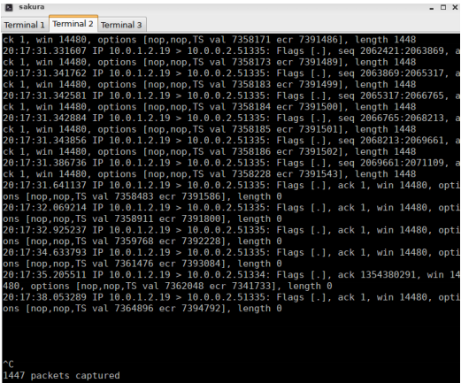

1. **Configure the queue and repeat the commands.**
   1. **Look for the first duplicate ack and check that the server retransmits the lost packets afterwards. Look at the trace captured by the client and check that effectively the packet was lost.**

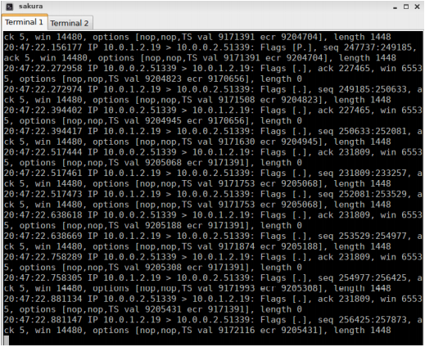 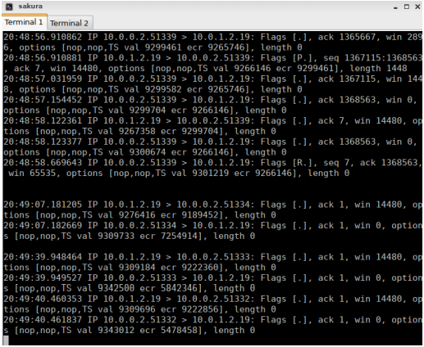

* 1. **Check that after the transmission the tcp window keep increasing slowly until there are losses again.**

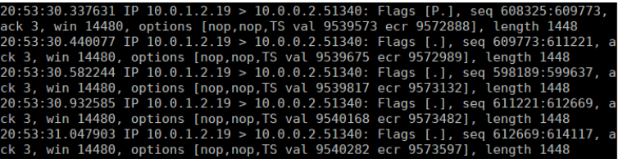

1. **Estimate the value of RTT in the three-way-handshaking and when the losses are produced. Why is it different?**

It is different because, when there are losses, we need to send the packets and their corresponding acks, so it is slower.